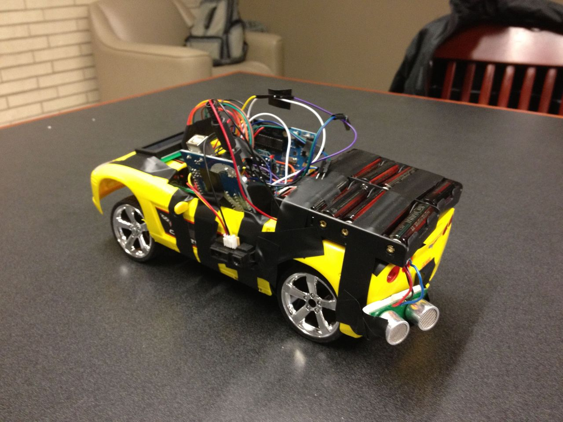

LED screen

LCD screen

IR Sensor

Circuitry

Batteries for Arduino and motors

Ultrasonic sensor

